Practical No 2 A

Aim: To perform linear and logistic regression as shallow neural networks using the Breast Cancer / Iris or similar dataset and train the models using SGD and Adam optimizers.

Code:
# Practical: Linear and Logistic Regression using TensorFlow

import tensorflow as tf
from tensorflow.keras.models import Sequential
from tensorflow.keras.layers import Dense, Input
from tensorflow.keras.optimizers import SGD, Adam

import numpy as np

from sklearn.datasets import load_breast_cancer
from sklearn.model_selection import train_test_split
from sklearn.preprocessing import StandardScaler

print("====================================")
print("LINEAR REGRESSION")
print("====================================")

# Sample dataset
X = np.array([[1], [2], [3], [4], [5]], dtype=float)
Y = np.array([[2], [4], [6], [8], [10]], dtype=float)

# Linear Regression Model
linear_model = Sequential([
Input(shape=(1,)),
Dense(1, activation='linear')
])

# Train using SGD
linear_model.compile(
optimizer=SGD(learning_rate=0.01),
loss='mse'
)

linear_model.fit(X, Y, epochs=200, verbose=0)

print("\nPrediction using SGD:")
print(linear_model.predict(np.array([[6]]), verbose=0))

# Train using Adam
linear_model.compile(
optimizer=Adam(learning_rate=0.01),
loss='mse'
)

linear_model.fit(X, Y, epochs=200, verbose=0)

print("\nPrediction using Adam:")
print(linear_model.predict(np.array([[6]]), verbose=0))

print("\n====================================")
print("LOGISTIC REGRESSION")
print("====================================")

# Load Breast Cancer Dataset
data = load_breast_cancer()

X = data.data
y = data.target

# Split Dataset
X_train, X_test, y_train, y_test = train_test_split(
X, y,
test_size=0.2,
random_state=42
)

# Feature Scaling
scaler = StandardScaler()

X_train = scaler.fit_transform(X_train)
X_test = scaler.transform(X_test)

# Logistic Regression Model
logistic_model = Sequential([
Input(shape=(30,)),
Dense(1, activation='sigmoid')
])

# Train using SGD
logistic_model.compile(
optimizer=SGD(learning_rate=0.01),
loss='binary_crossentropy',
metrics=['accuracy']
)

logistic_model.fit(X_train, y_train, epochs=50, verbose=0)

loss, accuracy = logistic_model.evaluate(X_test, y_test, verbose=0)

print("\nAccuracy using SGD:", round(accuracy * 100, 2), "%")

# Train using Adam
logistic_model.compile(
optimizer=Adam(learning_rate=0.001),
loss='binary_crossentropy',
metrics=['accuracy']
)

logistic_model.fit(X_train, y_train, epochs=50, verbose=0)

loss, accuracy = logistic_model.evaluate(X_test, y_test, verbose=0)

print("Accuracy using Adam:", round(accuracy * 100, 2), "%")

Output:

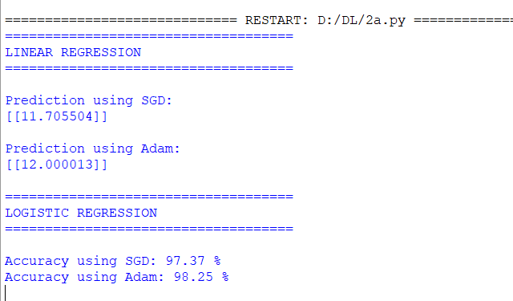

Practical No 2 B

Aim: Implement a linear/Logistic regression model using TensorFlow's low- level API (or tf. keras).

Code:
import tensorflow as tf
from tensorflow.keras.models import Sequential
from tensorflow.keras.layers import Dense, Input

from sklearn.datasets import load_breast_cancer
from sklearn.model_selection import train_test_split
from sklearn.preprocessing import StandardScaler

# Load Breast Cancer Dataset
data = load_breast_cancer()

X = data.data
y = data.target

# Split the dataset
X_train, X_test, y_train, y_test = train_test_split(
X, y,
test_size=0.2,
random_state=42
)

# Feature Scaling
scaler = StandardScaler()

X_train = scaler.fit_transform(X_train)
X_test = scaler.transform(X_test)

# Create Logistic Regression Model
model = Sequential([
Input(shape=(30,)),
Dense(1, activation='sigmoid')
])

# Compile the Model
model.compile(
optimizer='adam',
loss='binary_crossentropy',
metrics=['accuracy']
)

# Train the Model
model.fit(X_train, y_train, epochs=50, verbose=1)

# Evaluate the Model
loss, accuracy = model.evaluate(X_test, y_test)

print("\nTest Accuracy:", accuracy)

Output:
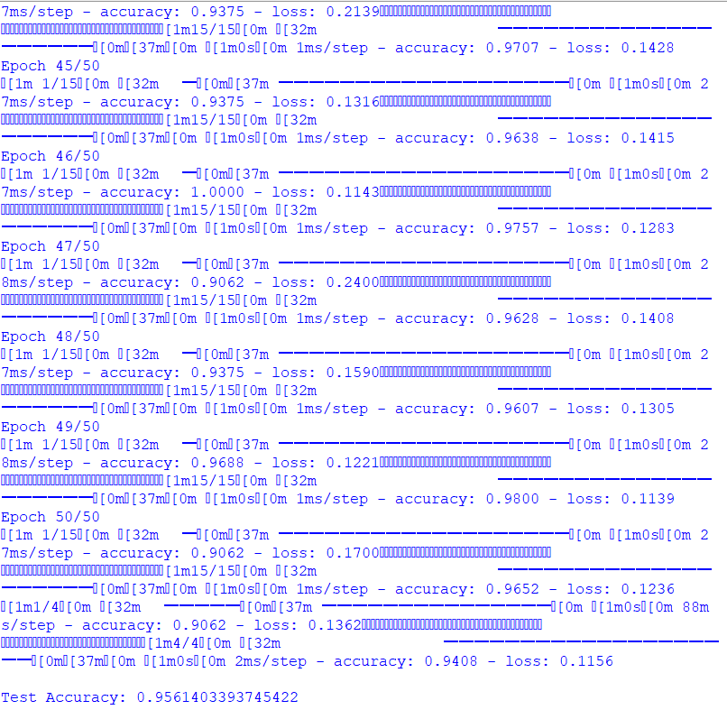
Practical No 2 C

Aim: Train the model on a toy dataset (e.g., housing prices vs. square footage or any other relevant dataset).

Code:
import tensorflow as tf
from tensorflow.keras.models import Sequential
from tensorflow.keras.layers import Dense, Input
import numpy as np

# Toy Dataset
# Square Footage
X = np.array([500, 800, 1000, 1200, 1500, 1800], dtype=float)

# House Prices (in thousands)
Y = np.array([100, 150, 200, 230, 300, 360], dtype=float)

# Normalize data
X = X / 1000
Y = Y / 100

# Create Linear Regression Model
model = Sequential([
Input(shape=(1,)),
Dense(1, activation='linear')
])

# Compile the model
model.compile(
optimizer='adam',
loss='mean_squared_error'
)

# Train the model
model.fit(X, Y, epochs=500, verbose=0)

# Predict price for a house of 1600 sq. ft.
new_area = np.array([[1.6]]) # 1600/1000

prediction = model.predict(new_area, verbose=0)

print("Predicted House Price (in thousands):")
print(prediction[0][0] * 100)
Output:
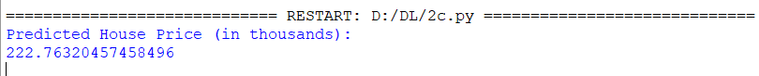

Practical No 2 D

Aim: Visualize the loss function and the learned linear relationship.

Code:
import tensorflow as tf
from tensorflow.keras.models import Sequential
from tensorflow.keras.layers import Dense, Input

import numpy as np
import matplotlib.pyplot as plt

# Toy Dataset
# Square Footage
X = np.array([500, 700, 900, 1100, 1300, 1500], dtype=float)

# House Price (in lakhs)
Y = np.array([20, 28, 36, 44, 52, 60], dtype=float)

# Normalize Data
X = X / 1000
Y = Y / 100

# Create Model
model = Sequential([
Input(shape=(1,)),
Dense(1, activation='linear')
])

# Compile Model
model.compile(
optimizer='adam',
loss='mean_squared_error'
)

# Train Model
history = model.fit(
X,
Y,
epochs=500,
verbose=0
)

# Predict values
predictions = model.predict(X, verbose=0)

# -----------------------------
# Plot 1 : Loss Function
# -----------------------------
plt.figure(figsize=(6,4))
plt.plot(history.history['loss'])
plt.title("Training Loss")
plt.xlabel("Epoch")
plt.ylabel("Loss")
plt.grid(True)
plt.show()

# -----------------------------
# Plot 2 : Linear Relationship
# -----------------------------
plt.figure(figsize=(6,4))
plt.scatter(X * 1000, Y * 100, label="Actual Data")
plt.plot(X * 1000, predictions * 100, label="Regression Line")
plt.title("House Price vs Square Footage")
plt.xlabel("Square Footage")
plt.ylabel("House Price (Lakhs)")
plt.legend()
plt.grid(True)
plt.show()

Output:

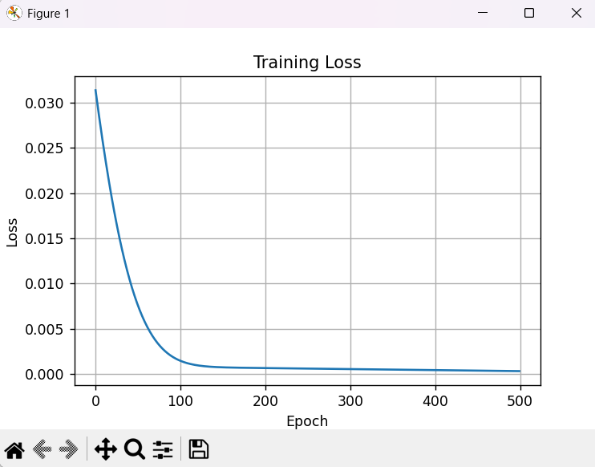

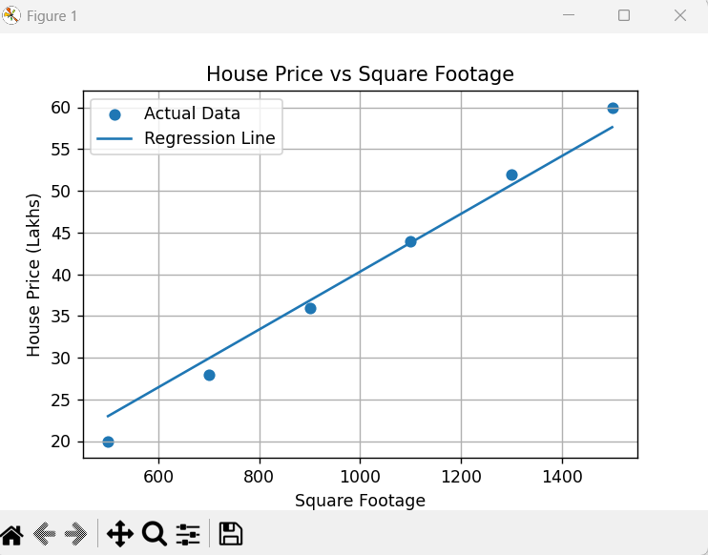

Practical No 2 D

Aim: Make predictions on new data points.

Code:
import tensorflow as tf
from tensorflow.keras.models import Sequential
from tensorflow.keras.layers import Dense, Input
import numpy as np

# Training Data
# Square Footage
X = np.array([500, 700, 900, 1100, 1300, 1500], dtype=float)

# House Price (in Lakhs)
Y = np.array([20, 28, 36, 44, 52, 60], dtype=float)

# Normalize Data
X = X / 1000
Y = Y / 100

# Create Model
model = Sequential([
Input(shape=(1,)),
Dense(1, activation='linear')
])

# Compile Model
model.compile(
optimizer='adam',
loss='mean_squared_error'
)

# Train Model
model.fit(X, Y, epochs=500, verbose=0)

# New Data Points (Square Footage)
new_data = np.array([[1.0], [1.2], [1.6]]) # 1000, 1200, 1600 sq. ft.

# Make Predictions
predictions = model.predict(new_data, verbose=0)

print("Predicted House Prices:")

for area, price in zip(new_data, predictions):
print(f"Square Footage: {area[0] * 1000:.0f} sq.ft. --> Estimated Price: {price[0] * 100:.2f} Lakhs")

Output:
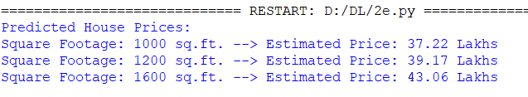

Practical No 3

Aim: Implement a Multilayer Perceptron (MLP) and study the effect of hidden layers, number of neurons, and activation functions on model performance

Code:
import tensorflow as tf
from tensorflow.keras.models import Sequential
from tensorflow.keras.layers import Dense, Input

from sklearn.datasets import load_iris
from sklearn.model_selection import train_test_split
from sklearn.preprocessing import StandardScaler

# Load Iris Dataset
iris = load_iris()

X = iris.data
y = iris.target

# Split Dataset
X_train, X_test, y_train, y_test = train_test_split(
X, y,
test_size=0.2,
random_state=42
)

# Feature Scaling
scaler = StandardScaler()

X_train = scaler.fit_transform(X_train)
X_test = scaler.transform(X_test)

# Create MLP Model
model = Sequential([
Input(shape=(4,)),
Dense(16, activation='relu'),
Dense(8, activation='relu'),
Dense(3, activation='softmax')
])

# Compile Model
model.compile(
optimizer='adam',
loss='sparse_categorical_crossentropy',
metrics=['accuracy']
)

# Train Model
history = model.fit(
X_train,
y_train,
epochs=100,
verbose=0
)

# Evaluate Model
loss, accuracy = model.evaluate(X_test, y_test, verbose=0)

print("Test Accuracy:", accuracy)

Output:

Practical No 4 A

Aim: To design and train a Convolutional Neural Network (CNN) for image classification using the MNIST or Fashion MNIST dataset

Code:
import tensorflow as tf
from tensorflow.keras.models import Sequential
from tensorflow.keras.layers import Conv2D, MaxPooling2D, Flatten, Dense

# Load MNIST Dataset
(X_train, y_train), (X_test, y_test) = tf.keras.datasets.mnist.load_data()

# Use a smaller dataset for faster training
X_train = X_train[:3000]
y_train = y_train[:3000]

X_test = X_test[:500]
y_test = y_test[:500]

# Normalize pixel values
X_train = X_train.astype("float32") / 255.0
X_test = X_test.astype("float32") / 255.0

# Reshape images
X_train = X_train.reshape(-1, 28, 28, 1)
X_test = X_test.reshape(-1, 28, 28, 1)

# Build CNN Model
model = Sequential([
tf.keras.Input(shape=(28, 28, 1)),

Conv2D(16, (3,3), activation='relu'),
MaxPooling2D((2,2)),

Flatten(),

Dense(32, activation='relu'),

Dense(10, activation='softmax')
])

# Compile Model
model.compile(
optimizer='adam',
loss='sparse_categorical_crossentropy',
metrics=['accuracy']
)

# Train Model
model.fit(
X_train,
y_train,
epochs=2,
batch_size=256,
verbose=2
)

# Evaluate Model
loss, accuracy = model.evaluate(X_test, y_test, verbose=0)

print("\nTest Accuracy:", round(accuracy * 100, 2), "%")

# Predict the first test image
prediction = model.predict(X_test[:1], verbose=0)

print("Predicted Digit :", prediction.argmax())
print("Actual Digit :", y_test[0])

Output:

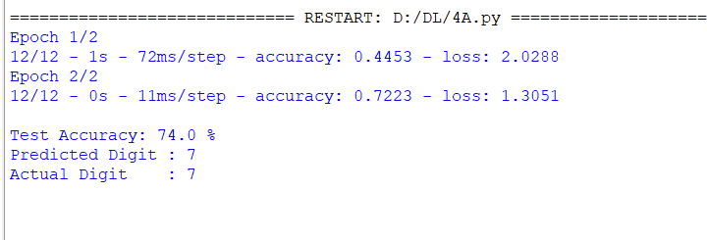
Practical No 4 B
Aim: Implementing deep neural network for performing binary classification task

Code:
import tensorflow as tf
from tensorflow.keras.models import Sequential
from tensorflow.keras.layers import Dense, Input
from sklearn.datasets import load_breast_cancer
from sklearn.model_selection import train_test_split
from sklearn.preprocessing import StandardScaler

# Load Breast Cancer Dataset
data = load_breast_cancer()

X = data.data
y = data.target

# Split Dataset
X_train, X_test, y_train, y_test = train_test_split(
X, y,
test_size=0.2,
random_state=42
)

# Feature Scaling
scaler = StandardScaler()

X_train = scaler.fit_transform(X_train)
X_test = scaler.transform(X_test)

# Build Deep Neural Network
model = Sequential([
Input(shape=(30,)),
Dense(64, activation='relu'),
Dense(32, activation='relu'),
Dense(16, activation='relu'),
Dense(1, activation='sigmoid')
])

# Compile Model
model.compile(
optimizer='adam',
loss='binary_crossentropy',
metrics=['accuracy']
)

# Train Model
model.fit(
X_train,
y_train,
epochs=20,
batch_size=32,
verbose=2
)

# Evaluate Model
loss, accuracy = model.evaluate(X_test, y_test, verbose=0)

print("\nTest Accuracy:", round(accuracy * 100, 2), "%")

# Predict First Test Sample
prediction = model.predict(X_test[:1], verbose=0)

print("\nPrediction Probability:", prediction[0][0])

if prediction[0][0] >= 0.5:
print("Predicted Class: Malignant")
else:
print("Predicted Class: Benign")

print("Actual Class:", data.target_names[y_test[0]])

Output:
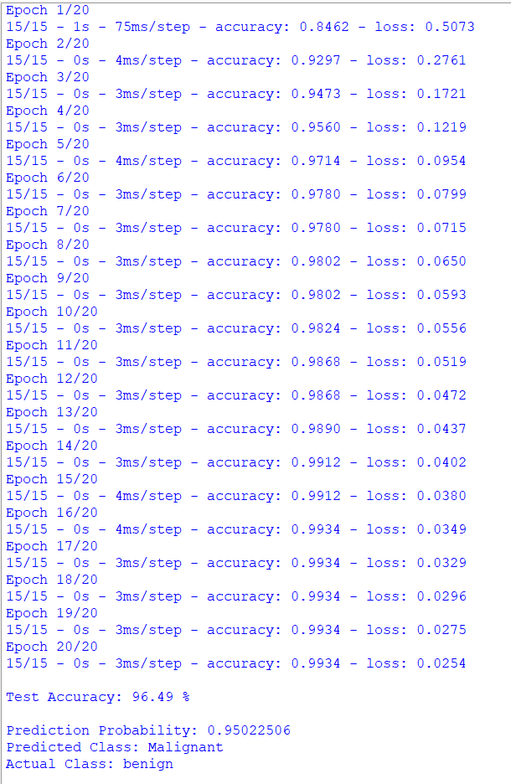

Practical No 5 A

Aim: Using a deep feed-forward network with two hidden layers for performing multiclass classification and predicting the class.

Code:
import tensorflow as tf
from tensorflow.keras.models import Sequential
from tensorflow.keras.layers import Dense, Input
from sklearn.datasets import load_iris
from sklearn.model_selection import train_test_split
from sklearn.preprocessing import StandardScaler
import numpy as np

# Load Iris Dataset
iris = load_iris()

X = iris.data
y = iris.target

# Split Dataset
X_train, X_test, y_train, y_test = train_test_split(
X, y,
test_size=0.2,
random_state=42
)

# Feature Scaling
scaler = StandardScaler()

X_train = scaler.fit_transform(X_train)
X_test = scaler.transform(X_test)

# Create Deep Neural Network
model = Sequential([
Input(shape=(4,)),
Dense(32, activation='relu'),
Dense(16, activation='relu'),
Dense(3, activation='softmax')
])

# Compile Model
model.compile(
optimizer='adam',
loss='sparse_categorical_crossentropy',
metrics=['accuracy']
)

# Train Model
model.fit(
X_train,
y_train,
epochs=50,
batch_size=8,
verbose=2
)

# Evaluate Model
loss, accuracy = model.evaluate(X_test, y_test, verbose=0)

print("\nTest Accuracy:", round(accuracy * 100, 2), "%")

# Predict First Test Sample
prediction = model.predict(X_test[:1], verbose=0)

predicted_class = np.argmax(prediction)

print("\nPredicted Class:", iris.target_names[predicted_class])
print("Actual Class :", iris.target_names[y_test[0]])

Output:

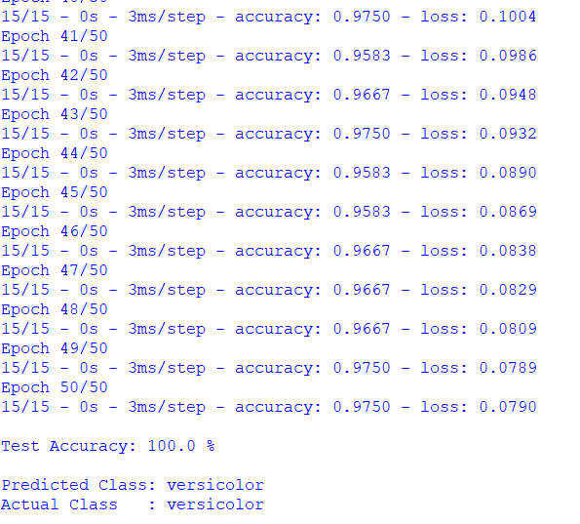

Practical No 5 B

Aim: Write a program to implement deep learning Techniques for image segmentation.

Code:
import tensorflow as tf
import numpy as np
import matplotlib.pyplot as plt

# Create a simple binary image
image = np.zeros((64, 64), dtype=np.float32)

# Draw a white square
image[16:48, 16:48] = 1.0

# Input Image
X = image.reshape(1, 64, 64, 1)

# Ground Truth Mask
Y = image.reshape(1, 64, 64, 1)

# Build CNN Model for Segmentation
model = tf.keras.Sequential([
tf.keras.layers.Input(shape=(64,64,1)),
tf.keras.layers.Conv2D(8, (3,3), activation='relu', padding='same'),
tf.keras.layers.Conv2D(8, (3,3), activation='relu', padding='same'),
tf.keras.layers.Conv2D(1, (1,1), activation='sigmoid', padding='same')
])

# Compile Model
model.compile(
optimizer='adam',
loss='binary_crossentropy',
metrics=['accuracy']
)

# Train Model
model.fit(X, Y, epochs=20, verbose=0)

# Predict Segmentation Mask
prediction = model.predict(X)

# Display Results
plt.figure(figsize=(9,3))

plt.subplot(1,3,1)
plt.imshow(image, cmap='gray')
plt.title("Input Image")

plt.subplot(1,3,2)
plt.imshow(Y[0,:,:,0], cmap='gray')
plt.title("Original Mask")

plt.subplot(1,3,3)
plt.imshow(prediction[0,:,:,0] > 0.5, cmap='gray')
plt.title("Predicted Mask")

plt.show()
Output:
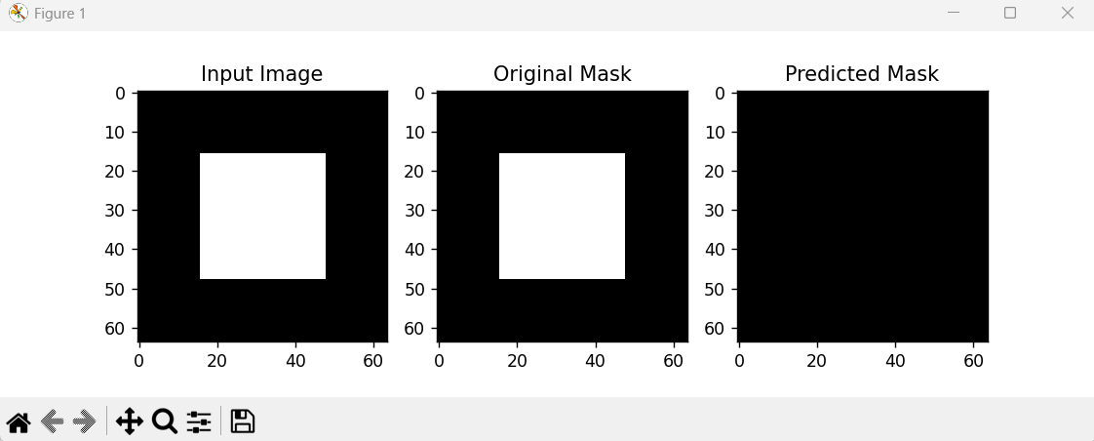

Practical No 6 A

Aim: To implement autoencoders and denoising autoencoders for dimensionality reduction and feature learning using the MNIST dataset.

Code:
import tensorflow as tf
import numpy as np
import matplotlib.pyplot as plt
from tensorflow.keras.layers import Input, Dense
from tensorflow.keras.models import Model

# Load MNIST Dataset
(x_train, _), (x_test, _) = tf.keras.datasets.mnist.load_data()

# Use smaller dataset for faster execution
x_train = x_train[:5000]
x_test = x_test[:10]

# Normalize images
x_train = x_train.astype("float32") / 255.0
x_test = x_test.astype("float32") / 255.0

# Flatten images
x_train = x_train.reshape((-1, 784))
x_test = x_test.reshape((-1, 784))

# -------------------------------
# AUTOENCODER
# -------------------------------

input_img = Input(shape=(784,))
encoded = Dense(64, activation='relu')(input_img)
decoded = Dense(784, activation='sigmoid')(encoded)

autoencoder = Model(input_img, decoded)

autoencoder.compile(
optimizer='adam',
loss='binary_crossentropy'
)

print("\nTraining Autoencoder...\n")

autoencoder.fit(
x_train,
x_train,
epochs=5,
batch_size=256,
verbose=2
)

# Reconstruct images
decoded_imgs = autoencoder.predict(x_test, verbose=0)

# -------------------------------
# DENOISING AUTOENCODER
# -------------------------------

noise_factor = 0.3

x_train_noisy = x_train + noise_factor * np.random.normal(size=x_train.shape)
x_test_noisy = x_test + noise_factor * np.random.normal(size=x_test.shape)

x_train_noisy = np.clip(x_train_noisy, 0., 1.)
x_test_noisy = np.clip(x_test_noisy, 0., 1.)

input_img2 = Input(shape=(784,))
encoded2 = Dense(64, activation='relu')(input_img2)
decoded2 = Dense(784, activation='sigmoid')(encoded2)

denoising_autoencoder = Model(input_img2, decoded2)

denoising_autoencoder.compile(
optimizer='adam',
loss='binary_crossentropy'
)

print("\nTraining Denoising Autoencoder...\n")

denoising_autoencoder.fit(
x_train_noisy,
x_train,
epochs=5,
batch_size=256,
verbose=2
)

denoised_imgs = denoising_autoencoder.predict(x_test_noisy, verbose=0)

# -------------------------------
# DISPLAY RESULTS
# -------------------------------

plt.figure(figsize=(12,6))

for i in range(5):

# Original Image
plt.subplot(3,5,i+1)
plt.imshow(x_test[i].reshape(28,28), cmap='gray')
plt.title("Original")
plt.axis("off")

# Autoencoder Output
plt.subplot(3,5,i+6)
plt.imshow(decoded_imgs[i].reshape(28,28), cmap='gray')
plt.title("Autoencoder")
plt.axis("off")

# Denoising Autoencoder Output
plt.subplot(3,5,i+11)
plt.imshow(denoised_imgs[i].reshape(28,28), cmap='gray')
plt.title("Denoised")
plt.axis("off")

plt.tight_layout()
plt.show()

Output:
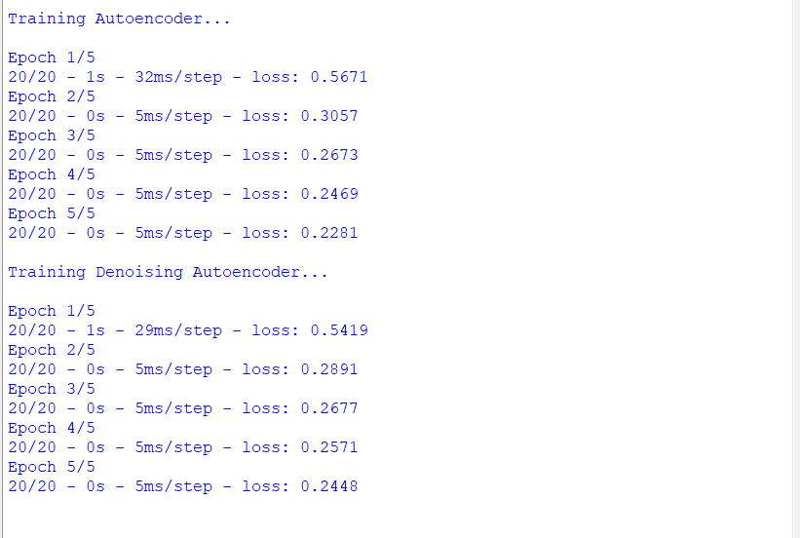

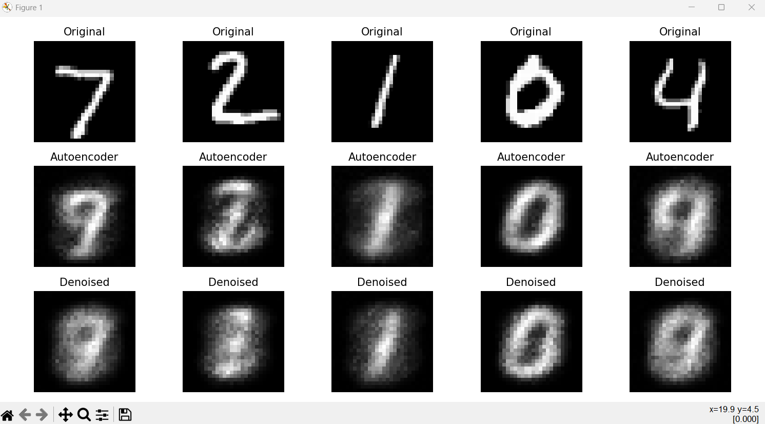

Practical No 6 B

Aim: Implement a linear/Logistic regression model using TensorFlow's low- level API (or tf. keras).

Code:
import tensorflow as tf
import matplotlib.pyplot as plt
from tensorflow.keras.layers import Input, Dense
from tensorflow.keras.models import Model

# Load MNIST Dataset
(x_train, _), (x_test, _) = tf.keras.datasets.mnist.load_data()

# Use smaller dataset for faster execution
x_train = x_train[:5000]
x_test = x_test[:10]

# Normalize pixel values
x_train = x_train.astype("float32") / 255.0
x_test = x_test.astype("float32") / 255.0

# Flatten images (28 x 28 = 784)
x_train = x_train.reshape((-1, 784))
x_test = x_test.reshape((-1, 784))

# Encoder
input_img = Input(shape=(784,))
encoded = Dense(64, activation='relu')(input_img)

# Decoder
decoded = Dense(784, activation='sigmoid')(encoded)

# Autoencoder Model
autoencoder = Model(input_img, decoded)

# Compile Model
autoencoder.compile(
optimizer='adam',
loss='binary_crossentropy'
)

# Train Model
autoencoder.fit(
x_train,
x_train,
epochs=10,
batch_size=256,
verbose=2
)

# Reconstruct Images
decoded_imgs = autoencoder.predict(x_test)

# Display Original and Reconstructed Images
plt.figure(figsize=(12,4))

for i in range(10):

# Original Image
plt.subplot(2,10,i+1)
plt.imshow(x_test[i].reshape(28,28), cmap='gray')
plt.title("Original")
plt.axis("off")

# Reconstructed Image
plt.subplot(2,10,i+11)
plt.imshow(decoded_imgs[i].reshape(28,28), cmap='gray')
plt.title("Output")
plt.axis("off")

plt.tight_layout()
plt.show()

Output:
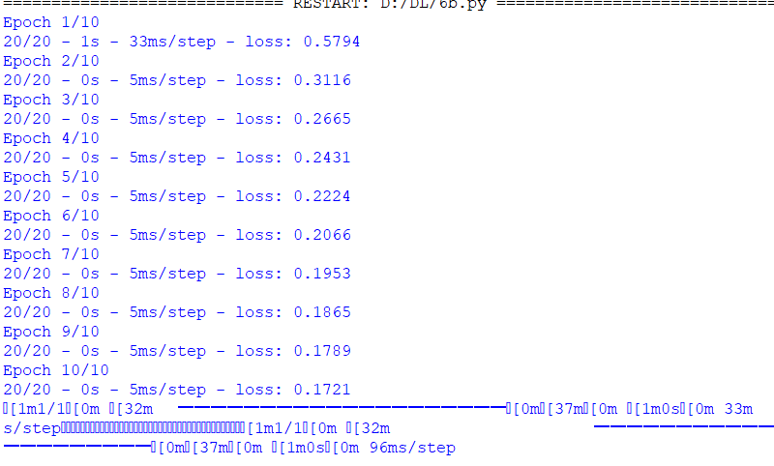
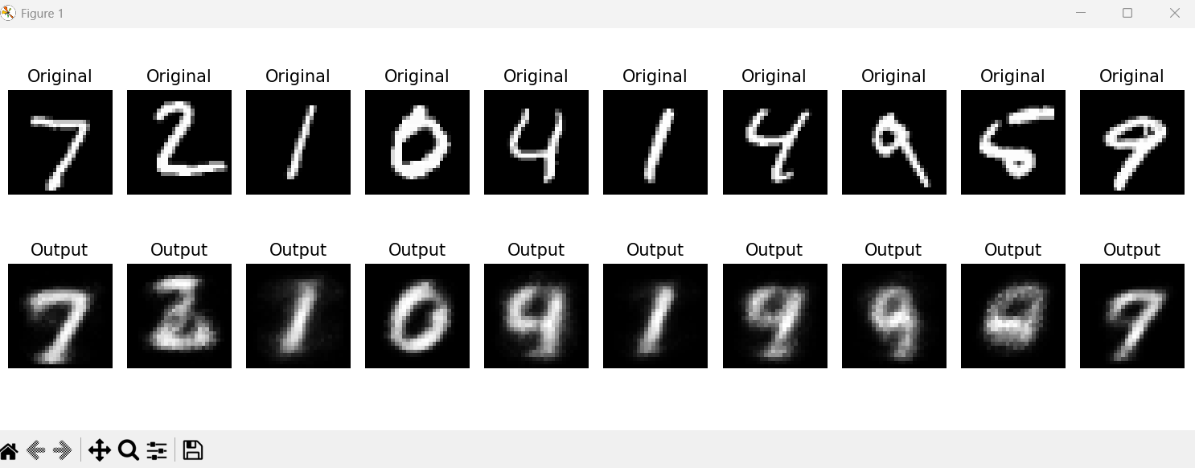

Practical No 6 C

Aim: Applying the Autoencoder algorithms for encoding real-world data

Code:
import tensorflow as tf
from tensorflow.keras.layers import Input, Dense
from tensorflow.keras.models import Model
from sklearn.datasets import load_iris
from sklearn.preprocessing import StandardScaler
import pandas as pd

# Load Iris Dataset
iris = load_iris()

X = iris.data

# Normalize Data
scaler = StandardScaler()
X = scaler.fit_transform(X)

# Encoder
input_layer = Input(shape=(4,))
encoded = Dense(2, activation='relu')(input_layer)

# Decoder
decoded = Dense(4, activation='linear')(encoded)

# Autoencoder Model
autoencoder = Model(input_layer, decoded)

# Encoder Model
encoder = Model(input_layer, encoded)

# Compile
autoencoder.compile(
optimizer='adam',
loss='mse'
)

# Train
autoencoder.fit(
X,
X,
epochs=100,
batch_size=16,
verbose=2
)

# Encode Data
encoded_data = encoder.predict(X)

# Display Encoded Features
df = pd.DataFrame(encoded_data, columns=["Feature 1", "Feature 2"])

print("\nEncoded Features:")
print(df.head())

Output:

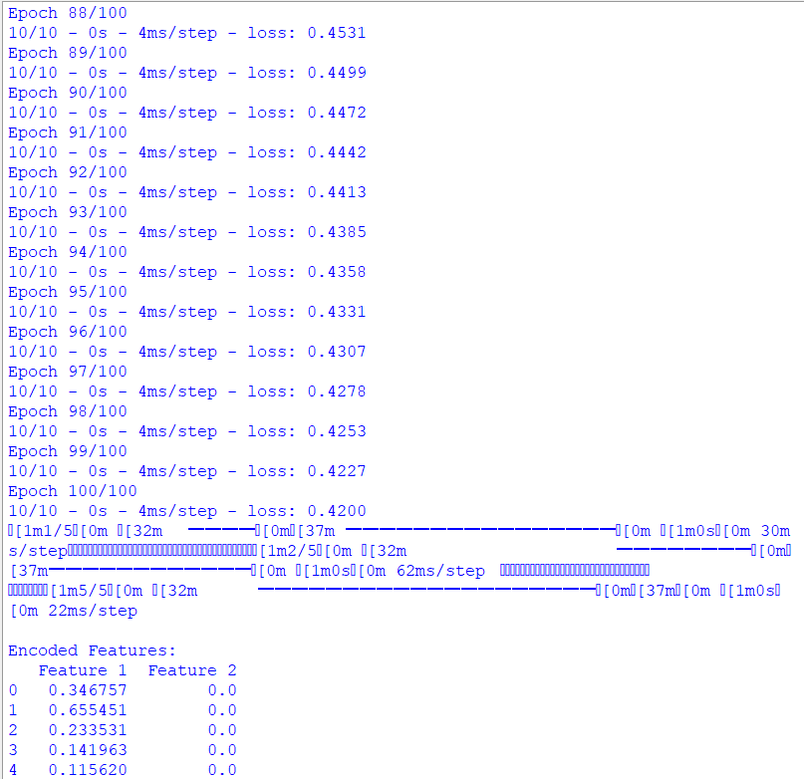
Practical No 7
Aim: Design and train a Variational Autoencoder (VAE) for learning latent representations and generating new data samples.

Code:
import tensorflow as tf
from tensorflow.keras import layers
import matplotlib.pyplot as plt

# Load MNIST Dataset
(x_train, _), (x_test, _) = tf.keras.datasets.mnist.load_data()

# Use smaller dataset for faster execution
x_train = x_train[:5000].astype("float32") / 255.0
x_test = x_test[:10].astype("float32") / 255.0

# Flatten Images
x_train = x_train.reshape((-1, 784))
x_test = x_test.reshape((-1, 784))

latent_dim = 2

# ---------------- Encoder ----------------
encoder_inputs = tf.keras.Input(shape=(784,))
x = layers.Dense(128, activation="relu")(encoder_inputs)

z_mean = layers.Dense(latent_dim)(x)
z_log_var = layers.Dense(latent_dim)(x)

# Sampling Layer
class Sampling(layers.Layer):
def call(self, inputs):
z_mean, z_log_var = inputs
epsilon = tf.random.normal(shape=tf.shape(z_mean))
return z_mean + tf.exp(0.5 * z_log_var) * epsilon

z = Sampling()([z_mean, z_log_var])

encoder = tf.keras.Model(encoder_inputs, [z_mean, z_log_var, z])

# ---------------- Decoder ----------------
latent_inputs = tf.keras.Input(shape=(latent_dim,))
x = layers.Dense(128, activation="relu")(latent_inputs)
decoder_outputs = layers.Dense(784, activation="sigmoid")(x)

decoder = tf.keras.Model(latent_inputs, decoder_outputs)

# ---------------- VAE ----------------
class VAE(tf.keras.Model):
def __init__(self, encoder, decoder):
super().__init__()
self.encoder = encoder
self.decoder = decoder

def train_step(self, data):

with tf.GradientTape() as tape:

z_mean, z_log_var, z = self.encoder(data)
reconstruction = self.decoder(z)

reconstruction_loss = tf.reduce_mean(
tf.keras.losses.binary_crossentropy(data, reconstruction)
) * 784

kl_loss = -0.5 * tf.reduce_mean(
1 + z_log_var - tf.square(z_mean) - tf.exp(z_log_var)
)

total_loss = reconstruction_loss + kl_loss

grads = tape.gradient(total_loss, self.trainable_weights)

self.optimizer.apply_gradients(
zip(grads, self.trainable_weights)
)

return {"loss": total_loss}

vae = VAE(encoder, decoder)

vae.compile(optimizer="adam")

# Train
vae.fit(
x_train,
epochs=10,
batch_size=256,
verbose=2
)

# Generate New Images
random_points = tf.random.normal(shape=(10, latent_dim))

generated = decoder.predict(random_points)

# Display Generated Images
plt.figure(figsize=(12,2))

for i in range(10):

plt.subplot(1,10,i+1)

plt.imshow(generated[i].reshape(28,28), cmap="gray")

plt.axis("off")

plt.show()

Output:
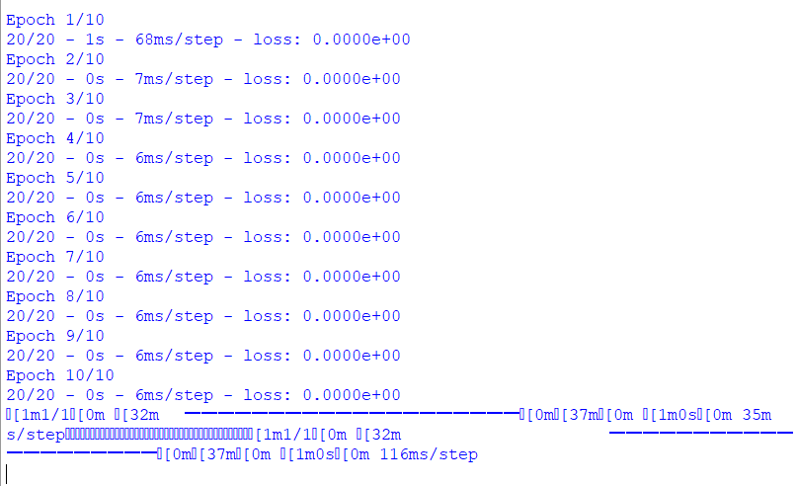

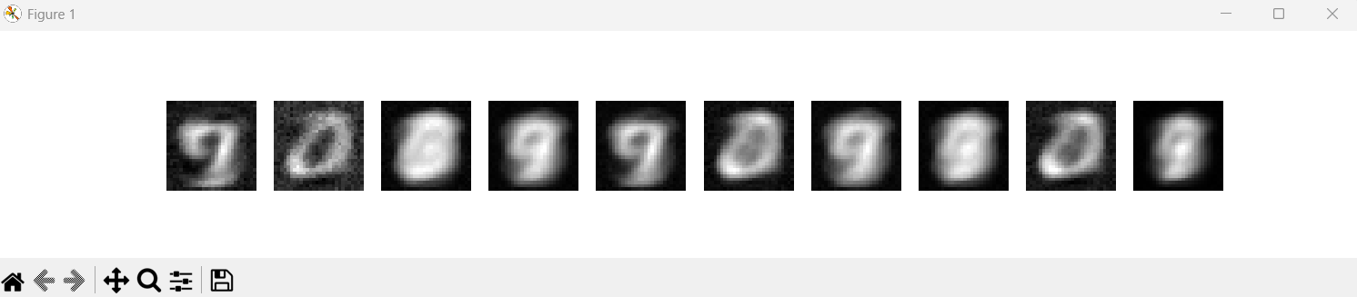

Practical No 8
Aim: Applying Generative Adversarial Networks for image generation and unsupervised tasks, implement a Generative Adversarial Network (GAN) for image generation using the MNIST or CIFAR 10 dataset.

Code:
import tensorflow as tf
from tensorflow.keras.models import Sequential
from tensorflow.keras.layers import Dense, Flatten, Reshape, LeakyReLU
import matplotlib.pyplot as plt

# -----------------------------
# Load MNIST Dataset
# -----------------------------
(X_train, _), (_, _) = tf.keras.datasets.mnist.load_data()

# Use 5000 images for faster training
X_train = X_train[:5000]

# Normalize images to [-1,1]
X_train = (X_train.astype("float32") - 127.5) / 127.5
X_train = X_train.reshape(-1, 28, 28, 1)

# Create dataset
dataset = tf.data.Dataset.from_tensor_slices(X_train)
dataset = dataset.shuffle(5000).batch(64)

# -----------------------------
# Generator
# -----------------------------
generator = Sequential([
tf.keras.Input(shape=(100,)),

Dense(256),
LeakyReLU(0.2),

Dense(512),
LeakyReLU(0.2),

Dense(784, activation="tanh"),
Reshape((28, 28, 1))
])

# -----------------------------
# Discriminator
# -----------------------------
discriminator = Sequential([
tf.keras.Input(shape=(28, 28, 1)),

Flatten(),

Dense(512),
LeakyReLU(0.2),

Dense(256),
LeakyReLU(0.2),

Dense(1, activation="sigmoid")
])

# Loss Function
loss_function = tf.keras.losses.BinaryCrossentropy()

# Optimizers
generator_optimizer = tf.keras.optimizers.Adam(0.0002, beta_1=0.5)
discriminator_optimizer = tf.keras.optimizers.Adam(0.0002, beta_1=0.5)

# -----------------------------
# Training Step
# -----------------------------
@tf.function
def train_step(images):

noise = tf.random.normal([images.shape[0], 100])

with tf.GradientTape() as gen_tape, tf.GradientTape() as disc_tape:

fake_images = generator(noise, training=True)

real_output = discriminator(images, training=True)
fake_output = discriminator(fake_images, training=True)

generator_loss = loss_function(
tf.ones_like(fake_output),
fake_output
)

real_loss = loss_function(
tf.ones_like(real_output),
real_output
)

fake_loss = loss_function(
tf.zeros_like(fake_output),
fake_output
)

discriminator_loss = real_loss + fake_loss

generator_gradients = gen_tape.gradient(
generator_loss,
generator.trainable_variables
)

discriminator_gradients = disc_tape.gradient(
discriminator_loss,
discriminator.trainable_variables
)

generator_optimizer.apply_gradients(
zip(generator_gradients,
generator.trainable_variables)
)

discriminator_optimizer.apply_gradients(
zip(discriminator_gradients,
discriminator.trainable_variables)
)

# -----------------------------
# Training
# -----------------------------
epochs = 30

for epoch in range(epochs):

for batch in dataset:
train_step(batch)

print("Epoch", epoch + 1, "/", epochs, "Completed")

# -----------------------------
# Generate New Images
# -----------------------------
noise = tf.random.normal([10, 100])

generated_images = generator(noise, training=False)

# -----------------------------
# Display Images
# -----------------------------
plt.figure(figsize=(12,4))

for i in range(10):

plt.subplot(2,5,i+1)

image = (generated_images[i, :, :, 0] + 1) / 2

plt.imshow(image,
cmap="gray",
vmin=0,
vmax=1)

plt.axis("off")

plt.suptitle("Generated Handwritten Digits using GAN")

plt.tight_layout()

plt.show()

Output:

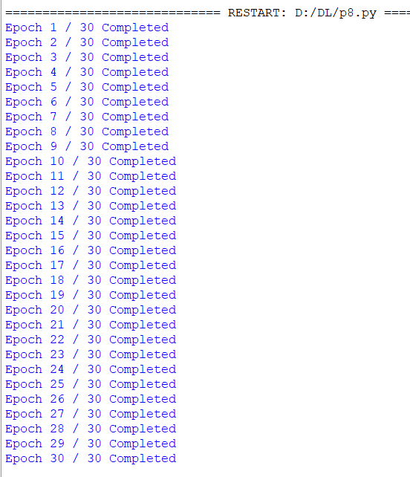
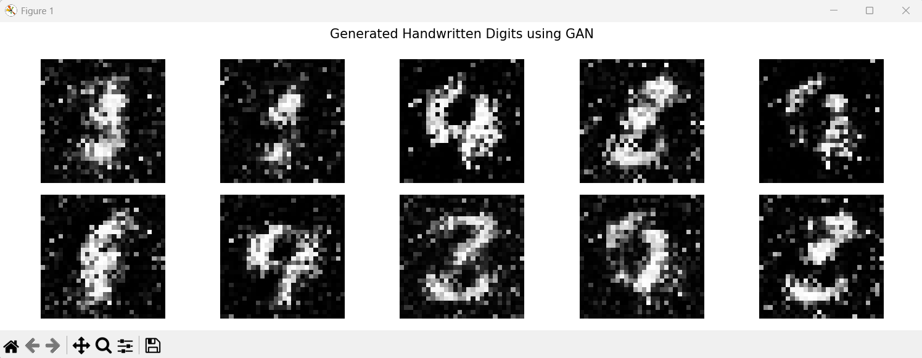

Practical No 9A
Aim: Write a program to predict a caption for a sample image using LSTM

Code:
import tensorflow as tf
import numpy as np

# Vocabulary
words = [
"a", "man", "woman", "boy", "girl",
"dog", "cat", "is", "playing",
"running", "walking", "with",
"ball", "park"
]

# Word Dictionary
word_to_id = {word: i+1 for i, word in enumerate(words)}
id_to_word = {i+1: word for i, word in enumerate(words)}

vocab_size = len(words) + 1

# Training Data
X = np.array([
[word_to_id["a"], word_to_id["man"], word_to_id["is"]],
[word_to_id["a"], word_to_id["woman"], word_to_id["is"]],
[word_to_id["a"], word_to_id["boy"], word_to_id["is"]],
[word_to_id["a"], word_to_id["girl"], word_to_id["is"]],
[word_to_id["a"], word_to_id["dog"], word_to_id["is"]],
[word_to_id["a"], word_to_id["cat"], word_to_id["is"]]
])

y = np.array([
word_to_id["running"],
word_to_id["walking"],
word_to_id["playing"],
word_to_id["walking"],
word_to_id["running"],
word_to_id["playing"]
])

# Build LSTM Model
model = tf.keras.Sequential([
tf.keras.layers.Embedding(vocab_size, 16),
tf.keras.layers.LSTM(32),
tf.keras.layers.Dense(vocab_size, activation="softmax")
])

# Compile Model
model.compile(
optimizer="adam",
loss="sparse_categorical_crossentropy",
metrics=["accuracy"]
)

# Train Model
model.fit(X, y, epochs=300, verbose=0)

# -----------------------------
# Sample Image (Assume image contains a man)
# -----------------------------
sample = np.array([
[
word_to_id["a"],
word_to_id["man"],
word_to_id["is"]
]
])

prediction = model.predict(sample, verbose=0)

predicted_word = id_to_word[np.argmax(prediction)]

caption = "A man is " + predicted_word

print("Predicted Caption:")
print(caption)

Output:

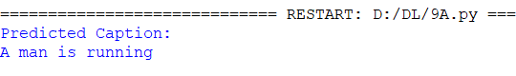

Practical No 9B
Aim: Design and train a Long Short Term Memory (LSTM) network to learn long term dependencies in sequential data.

Code:
import tensorflow as tf
import numpy as np

# -----------------------------
# Create Sequential Data
# -----------------------------
sequence = np.array([1,2,3,4,5,6,7,8,9,10])

X = []
y = []

# Create input-output pairs
for i in range(len(sequence)-3):
X.append(sequence[i:i+3])
y.append(sequence[i+3])

X = np.array(X)
y = np.array(y)

# Reshape for LSTM
X = X.reshape((X.shape[0], X.shape[1], 1))

# -----------------------------
# Build LSTM Model
# -----------------------------
model = tf.keras.Sequential([
tf.keras.layers.LSTM(32, input_shape=(3,1)),
tf.keras.layers.Dense(1)
])

# Compile Model
model.compile(
optimizer='adam',
loss='mse'
)

# Train Model
model.fit(
X,
y,
epochs=300,
verbose=0
)

# -----------------------------
# Prediction
# -----------------------------
test = np.array([8,9,10]).reshape((1,3,1))

prediction = model.predict(test, verbose=0)

print("Input Sequence : [8 9 10]")
print("Predicted Next Number :", round(prediction[0][0]))

Output:
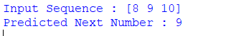

Practical No 10 A
Aim: Demonstrate recurrent neural network that learns to perform sequence analysis for stock price.(google stock price.

Dataset:

Date | Open | High | Low | Close | Volume
01-01-2025 | 100 | 102 | 99 | 101 | 1500000
02-01-2025 | 101 | 104 | 100 | 103 | 1515000
03-01-2025 | 103 | 105 | 101 | 104 | 1520000
04-01-2025 | 102 | 104 | 101 | 103 | 1535000
05-01-2025 | 104 | 107 | 103 | 106 | 1540000
06-01-2025 | 106 | 108 | 104 | 107 | 1555000
07-01-2025 | 105 | 107 | 103 | 104 | 1560000
08-01-2025 | 107 | 109 | 106 | 108 | 1570000
09-01-2025 | 108 | 110 | 107 | 109 | 1585000
10-01-2025 | 110 | 112 | 109 | 111 | 1600000

Save the file as: Google_Stock_Price_Train.csv

Code:
import numpy as np
import pandas as pd
from sklearn.preprocessing import MinMaxScaler
import tensorflow as tf
from tensorflow.keras.models import Sequential
from tensorflow.keras.layers import LSTM, Dense

# -----------------------------
# Load Dataset
# -----------------------------
dataset = pd.read_csv("Google_Stock_Price_Train.csv")

print(dataset)

# Use 'Open' column
training_set = dataset.iloc[:, 1:2].values

# -----------------------------
# Feature Scaling
# -----------------------------
scaler = MinMaxScaler(feature_range=(0,1))
training_set = scaler.fit_transform(training_set)

# -----------------------------
# Create Training Data
# -----------------------------
window_size = 3

X_train = []
y_train = []

for i in range(window_size, len(training_set)):
X_train.append(training_set[i-window_size:i, 0])
y_train.append(training_set[i, 0])

X_train = np.array(X_train)
y_train = np.array(y_train)

# Reshape for LSTM
X_train = X_train.reshape((X_train.shape[0], X_train.shape[1], 1))

print("X_train Shape :", X_train.shape)
print("y_train Shape :", y_train.shape)

# -----------------------------
# Build LSTM Model
# -----------------------------
model = Sequential([
LSTM(50, input_shape=(window_size,1)),
Dense(1)
])

# -----------------------------
# Compile Model
# -----------------------------
model.compile(
optimizer='adam',
loss='mean_squared_error'
)

# -----------------------------
# Train Model
# -----------------------------
model.fit(
X_train,
y_train,
epochs=100,
batch_size=1,
verbose=1
)

# -----------------------------
# Predict Next Stock Price
# -----------------------------
last_days = training_set[-window_size:]

X_test = np.array([last_days])

prediction = model.predict(X_test)

prediction = scaler.inverse_transform(prediction)

print("\nPredicted Next Google Stock Price:")
print(round(prediction[0][0], 2))

Output:

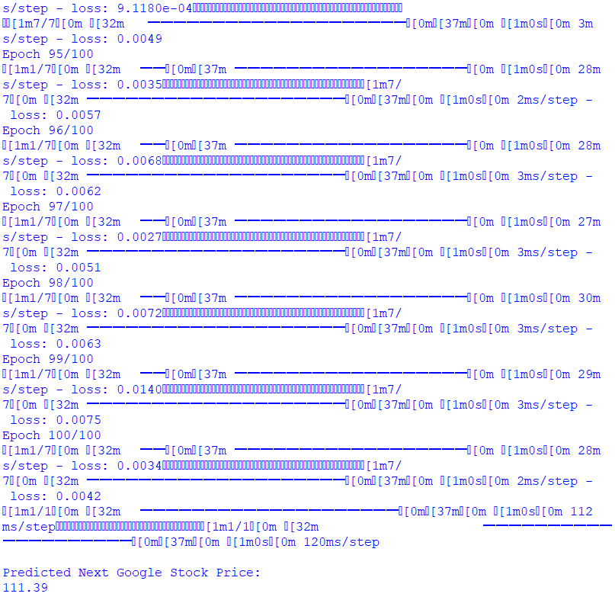

Practical No 10 B
Aim: Implement a Recurrent Neural Network (RNN) for sequence modeling tasks such as text classification or time-series prediction

Code:
import numpy as np
import tensorflow as tf
from tensorflow.keras.models import Sequential
from tensorflow.keras.layers import SimpleRNN, Dense
from sklearn.preprocessing import MinMaxScaler

# -----------------------------
# Sample Time-Series Data
# -----------------------------
data = np.array([
100,102,101,103,105,106,108,110,111,113,
115,116,118,120,121,123,125,127,129,130
], dtype=float)

# -----------------------------
# Normalize Data
# -----------------------------
scaler = MinMaxScaler()
data = scaler.fit_transform(data.reshape(-1,1))

# -----------------------------
# Create Sequences
# -----------------------------
window_size = 3

X = []
y = []

for i in range(window_size, len(data)):
X.append(data[i-window_size:i,0])
y.append(data[i,0])

X = np.array(X)
y = np.array(y)

# Reshape for RNN
X = X.reshape((X.shape[0], X.shape[1], 1))

# -----------------------------
# Build RNN Model
# -----------------------------
model = Sequential([
SimpleRNN(16, input_shape=(window_size,1)),
Dense(1)
])

# -----------------------------
# Compile
# -----------------------------
model.compile(
optimizer='adam',
loss='mean_squared_error'
)

# -----------------------------
# Train
# -----------------------------
model.fit(
X,
y,
epochs=200,
verbose=0
)

# -----------------------------
# Predict Next Value
# -----------------------------
test = np.array([[127,129,130]])
test = scaler.transform(test.reshape(-1,1))
test = test.reshape((1,window_size,1))

prediction = model.predict(test, verbose=0)

prediction = scaler.inverse_transform(prediction)

print("Input Values : [127 129 130]")
print("Predicted Next Value :", round(prediction[0][0],2))

Output:
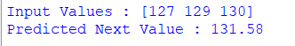

Practical No 10C
Aim: Write a program for character recognition using RNN and compare it with CNN

Code:
import tensorflow as tf
from tensorflow.keras.models import Sequential
from tensorflow.keras.layers import SimpleRNN, Conv2D, MaxPooling2D
from tensorflow.keras.layers import Flatten, Dense
import matplotlib.pyplot as plt
import numpy as np

# ------------------------------------
# Load MNIST Dataset
# ------------------------------------
(X_train, y_train), (X_test, y_test) = tf.keras.datasets.mnist.load_data()

# Use smaller dataset for faster execution
X_train = X_train[:10000]
y_train = y_train[:10000]

X_test = X_test[:2000]
y_test = y_test[:2000]

# Normalize
X_train = X_train / 255.0
X_test = X_test / 255.0

# =====================================================
# RNN MODEL
# =====================================================

print("\n========== RNN MODEL ==========")

rnn_model = Sequential([
tf.keras.Input(shape=(28,28)),
SimpleRNN(64),
Dense(10, activation='softmax')
])

rnn_model.compile(
optimizer='adam',
loss='sparse_categorical_crossentropy',
metrics=['accuracy']
)

rnn_model.fit(
X_train,
y_train,
epochs=3,
batch_size=128,
verbose=1
)

rnn_loss, rnn_accuracy = rnn_model.evaluate(
X_test,
y_test,
verbose=0
)

# =====================================================
# CNN MODEL
# =====================================================

print("\n========== CNN MODEL ==========")

# Reshape images
X_train_cnn = X_train.reshape(-1,28,28,1)
X_test_cnn = X_test.reshape(-1,28,28,1)

cnn_model = Sequential([
tf.keras.Input(shape=(28,28,1)),
Conv2D(16,(3,3),activation='relu'),
MaxPooling2D((2,2)),
Flatten(),
Dense(32,activation='relu'),
Dense(10,activation='softmax')
])

cnn_model.compile(
optimizer='adam',
loss='sparse_categorical_crossentropy',
metrics=['accuracy']
)

cnn_model.fit(
X_train_cnn,
y_train,
epochs=3,
batch_size=128,
verbose=1
)

cnn_loss, cnn_accuracy = cnn_model.evaluate(
X_test_cnn,
y_test,
verbose=0
)

# =====================================================
# Prediction
# =====================================================

rnn_prediction = rnn_model.predict(X_test[:1], verbose=0)
cnn_prediction = cnn_model.predict(X_test_cnn[:1], verbose=0)

print("\nActual Digit :", y_test[0])
print("RNN Prediction :", np.argmax(rnn_prediction))
print("CNN Prediction :", np.argmax(cnn_prediction))

# =====================================================
# Show Test Image
# =====================================================

plt.imshow(X_test[0], cmap='gray')
plt.title("Test Image")
plt.axis("off")
plt.show()

# =====================================================
# Accuracy Comparison
# =====================================================

print("\n===============================")
print("MODEL COMPARISON")
print("===============================")

print("RNN Accuracy :", round(rnn_accuracy*100,2), "%")
print("CNN Accuracy :", round(cnn_accuracy*100,2), "%")

print("\nConclusion:")
if cnn_accuracy > rnn_accuracy:
print("CNN performs better than RNN for character recognition.")
else:
print("RNN performs better than CNN.")

Output:
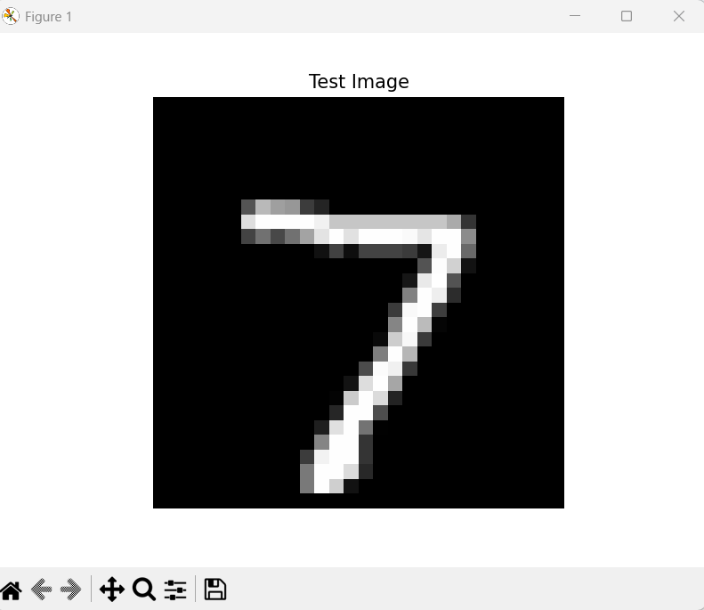

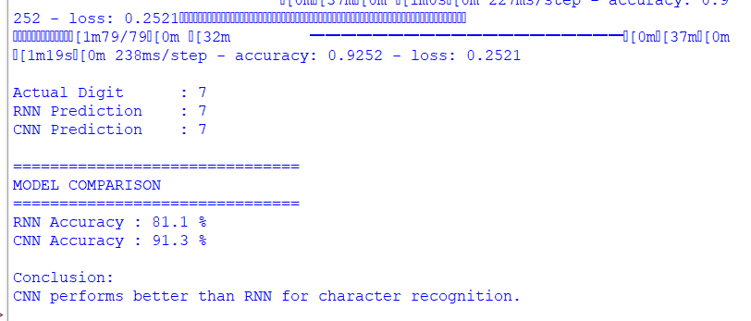

Practical No 11
Aim: Apply regularization techniques such as L2 weight decay, Dropout, and Early Stopping to reduce overfitting in neural networks using the Fashion MNIST dataset

Code:
import tensorflow as tf
from tensorflow.keras.models import Sequential
from tensorflow.keras.layers import Dense, Flatten, Dropout
from tensorflow.keras.regularizers import l2
from tensorflow.keras.callbacks import EarlyStopping

# Load MNIST Dataset
(X_train, y_train), (X_test, y_test) = tf.keras.datasets.mnist.load_data()

# Normalize
X_train = X_train / 255.0
X_test = X_test / 255.0

# Small dataset for fast training
X_train = X_train[:2000]
y_train = y_train[:2000]

X_test = X_test[:500]
y_test = y_test[:500]

# Build Model
model = Sequential([
Flatten(input_shape=(28,28)),

Dense(64, activation='relu',
kernel_regularizer=l2(0.001)), # L2 Regularization

Dropout(0.3), # Dropout

Dense(32, activation='relu',
kernel_regularizer=l2(0.001)),

Dense(10, activation='softmax')
])

# Compile
model.compile(
optimizer='adam',
loss='sparse_categorical_crossentropy',
metrics=['accuracy']
)

# Early Stopping
early_stop = EarlyStopping(
monitor='val_loss',
patience=1,
restore_best_weights=True
)

# Train
model.fit(
X_train,
y_train,
epochs=5,
batch_size=128,
validation_split=0.2,
callbacks=[early_stop],
verbose=2
)

# Evaluate
loss, accuracy = model.evaluate(X_test, y_test, verbose=0)

print("\nTest Accuracy:", round(accuracy*100,2), "%")

# Prediction
prediction = model.predict(X_test[:1], verbose=0)

print("Predicted Digit:", prediction.argmax())
print("Actual Digit :", y_test[0])

Output:
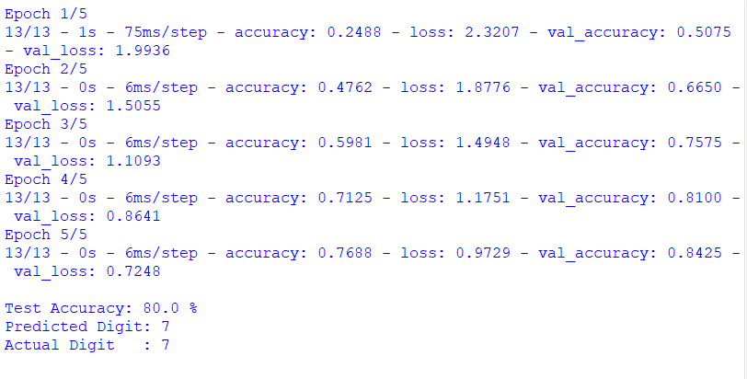

Practical No 12
Aim: To study and implement a Boltzmann Machine for modeling probability distributions over binary data.

Code:
import numpy as np
from sklearn.neural_network import BernoulliRBM

# -----------------------------
# Binary Dataset
# -----------------------------
X = np.array([
[1,1,1,0,0,0],
[1,1,0,0,0,0],
[1,0,1,0,0,0],
[0,0,0,1,1,1],
[0,0,0,1,1,0],
[0,0,0,1,0,1]
])

print("Training Data:\n")
print(X)

# -----------------------------
# Create RBM Model
# -----------------------------
rbm = BernoulliRBM(
n_components=2,
learning_rate=0.1,
n_iter=100,
random_state=0
)

# -----------------------------
# Train Model
# -----------------------------
rbm.fit(X)

print("\nTraining Completed Successfully!")

# -----------------------------
# Hidden Representation
# -----------------------------
hidden = rbm.transform(X)

print("\nHidden Features:\n")
print(np.round(hidden,3))

# -----------------------------
# Reconstruction
# -----------------------------
reconstructed = rbm.gibbs(X)

print("\nReconstructed Data:\n")
print(np.round(reconstructed))

Output:
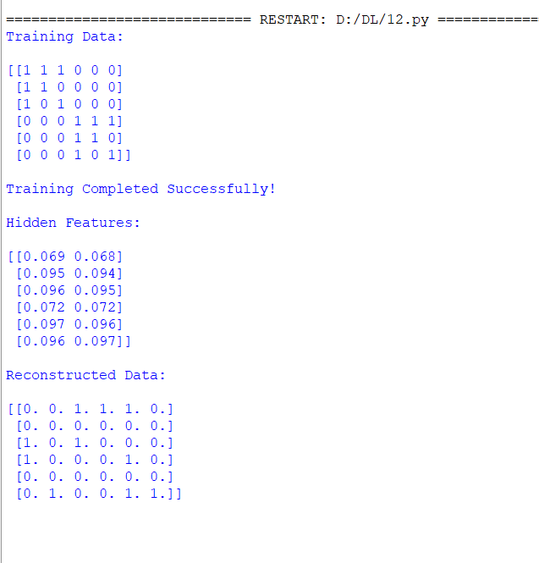

Practical No 13
Aim: To implement a Restricted Boltzmann Machine (RBM) for unsupervised feature learning using Contrastive Divergence

Code:
import matplotlib.pyplot as plt
from sklearn.datasets import load_digits
from sklearn.neural_network import BernoulliRBM
from sklearn.preprocessing import MinMaxScaler

# --------------------------------
# Load Digits Dataset
# --------------------------------

digits = load_digits()

X = digits.data
y = digits.target

# --------------------------------
# Normalize Data
# --------------------------------

scaler = MinMaxScaler()

X = scaler.fit_transform(X)

# Convert to Binary Data
X = (X > 0.5).astype(int)

# --------------------------------
# Create RBM
# --------------------------------

rbm = BernoulliRBM(
n_components=32,
learning_rate=0.05,
batch_size=20,
n_iter=20,
random_state=0,
verbose=True
)

# --------------------------------
# Train RBM
# --------------------------------

print("Training RBM using Contrastive Divergence...\n")

rbm.fit(X)

print("\nTraining Completed Successfully!")

# --------------------------------
# Learn Hidden Features
# --------------------------------

hidden = rbm.transform(X)

print("\nShape of Hidden Features :", hidden.shape)

# --------------------------------
# Display Original Image
# --------------------------------

plt.figure(figsize=(8,4))

plt.subplot(1,2,1)
plt.imshow(digits.images[0], cmap="gray")
plt.title("Original Digit")
plt.axis("off")

# --------------------------------
# Display Learned Features
# --------------------------------

plt.subplot(1,2,2)
plt.imshow(hidden[0].reshape(4,8), cmap="gray")
plt.title("Learned Features")
plt.axis("off")

plt.show()

Output:
